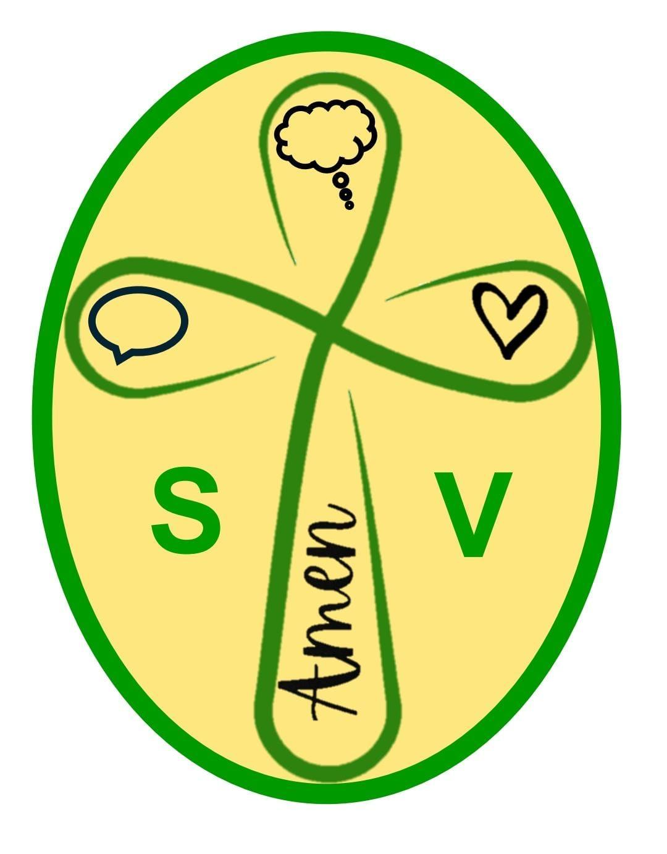
St Vincent's
Catholic Primary School
Benedict’s Law
“We honor the dignity of every person by caring for one another and keeping everyone safe.”
Visitor and Volunteer Declaration
Please complete before your visit. By sharing this information, you help us protect each person’s safety, dignity and full participation in school life.

Name: | Visit date:
ALLERGIES / DIETARY / MEDICAL INFORMATION
Do you have any allergies, dietary requirements or medical conditions the school should know about to help keep you safe?

☐ No ☐ Yes — details below
Please include the allergen/condition, likely reaction and any important avoidance measures.

2 EMERGENCY MEDICATION

Does this allergy or condition require emergency medication (for example an adrenaline auto-injector/EpiPen, antihistamine or inhaler)?

☐ No ☐ Yes — medication/details:

MEDICATION ON SITE

Will you be carrying your medication with you whilst on site?

☐ Yes ☐ No ☐ Not applicable
EMERGENCY CONTACT

Name: Telephone:

ALLERGY AWARE SCHOOL
• Please check food labels carefully • Do not share food • Ask a member of staff if unsure
CONSENT & DECLARATION
I understand that this information will be shared with relevant staff on a need-to-know basis to support my safety on school premises. In keeping with the Catholic principle of the dignity of the human person, every person should be valued, respected, included and supported to participate safely in our school community.
Signature: _________________________________ Date: ______________________

Kindness • Respect • Inclusion • Safety • Community

